1. Steps:
   1. 01: Include dependency:  
      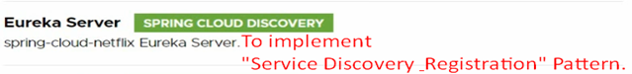  
        
      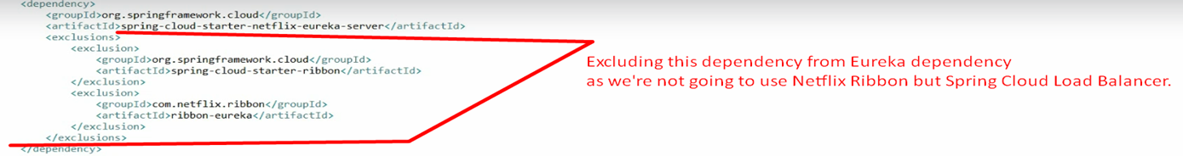
   2. **application.properties  
      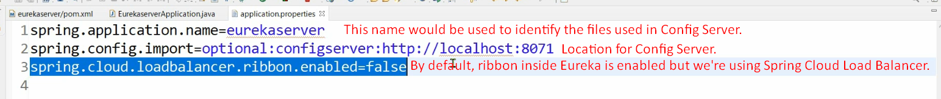**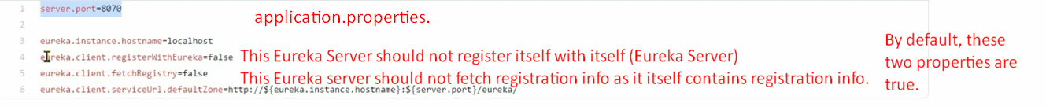
   3. @EnableEurekaServer

